Name: ……………………………………………….. ( ) Class: ……… Date: ………………….

|  |  |  |
| --- | --- | --- |
| **3.1** | **Problem Analysis** | **Problem Statements** |

To understand a problem, we first need to specify its:

1. Input(s) and requirements for valid input(s)

* Include only the important data or information that is needed for the output(s) and exclude any irrelevant details
* State the range of valid or acceptable values for input(s)

1. Output(s) and requirements for correct output(s)

* Write a description of the final answer that includes all the important features that the output is required to have

It is also recommended to give names to each piece of input.

**Specifying the Inputs**

1. You have been asked to find the greatest common divisor of two positive whole numbers.

Which set of input(s) is the most appropriate for this problem?

|  |  |  |  |  |  |
| --- | --- | --- | --- | --- | --- |
|  | **A** | **Input** |  | **B** | **Input** |
|  |  | * *x*: a number * *y*: a number |  |  | * *x*: a whole number * *y*: a whole number |
|  |  |  |  |  |  |
|  | **C** | **Input** |  | **D** | **Input** |
|  |  | * *x*: a positive whole number * *y*: a positive whole number |  |  | * *x*: a positive whole number * *y*: a positive whole number * *gcd*: the greatest common divisor of *x* and *y* |

1. You have been asked to calculate the sum of some integers. The number of integers is not known ahead of time and may be large.

Which set of input(s) is the LEAST appropriate for this problem?

|  |  |  |  |  |  |
| --- | --- | --- | --- | --- | --- |
|  | **A** | **Input** |  | **B** | **Input** |
|  |  | * *integers*: list of integers |  |  | * *integers*: table of integers |
|  |  |  |  |  |  |
|  | **C** | **Input** |  | **D** | **Input** |
|  |  | * *integer1*: first integer * *integer2*: second integer * *integer3*: third integer |  |  | * *n*: a positive whole number * *integer*: an integer (provided *n* times) |

1. The events for your school’s Games Day use equipment that are fixed at different locations around the school. You have been asked to plan the order in which these events should be held to minimise the amount of travelling needed from event to event. A specific example of this problem is illustrated below:

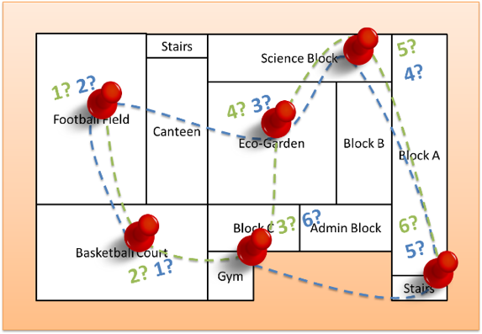

Which set of input(s) is the most appropriate for this problem?

|  |  |  |  |  |  |
| --- | --- | --- | --- | --- | --- |
|  | **A** | **Input** |  | **B** | **Input** |
|  |  | * *Distances*: table of event names and the travelling distance between any two events |  |  | * *Equipment*: table of event names and the equipment used for each event |
|  |  |  |  |  |  |
|  | **C** | **Input** |  | **D** | **Input** |
|  |  | * *Map*: map of school * *Events*: list of event names |  |  | * *Teachers*: table of event names and the teachers-in-charge for each event |

1. A large number of crates of different colours need to be transported onto a ship using nets. However, the total weight of crates is too large for a single net. You have been asked to split the crates into as few groups as possible while ensuring that the weight of crates in each group does not exceed the capacity of a net. A specific example of this problem is illustrated below:

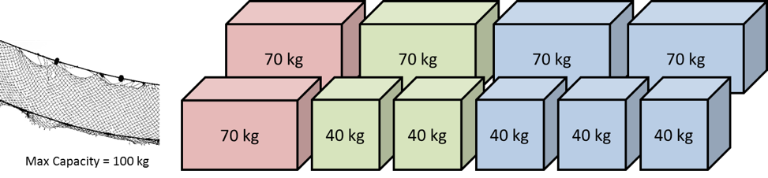

Specify the input(s), stating clearly the requirements for valid input(s), for this problem.

………………………………………………………………………………………………………………………………………………………  
  
………………………………………………………………………………………………………………………………………………………

………………………………………………………………………………………………………………………………………………………

1. You are given the following problem:

Given two English letter sequences, determine if the second letter sequence is a *permutation* (i.e. is either identical or a rearrangement) of the first letter sequence.

For instance, if the first sequence is “aabb” and the second sequence is “abab”, then the second sequence is a permutation of the first sequence. On the other hand, if the first sequence is “aabb” and the second sequence is “aaab”, then the second sequence is NOT a permutation of the first sequence.

Specify the input(s), stating clearly the requirements for valid input(s), for this problem.

………………………………………………………………………………………………………………………………………………………  
  
………………………………………………………………………………………………………………………………………………………

………………………………………………………………………………………………………………………………………………………

1. You are given the following problem:

Given a list of English letter sequences, find how many letter sequences (not including the first sequence) are permutations of the first letter sequence in the list.

Specify the input(s), stating clearly the requirements for valid input(s), for this problem.

………………………………………………………………………………………………………………………………………………………

………………………………………………………………………………………………………………………………………………………  
  
………………………………………………………………………………………………………………………………………………………

**Specifying the Outputs**

1. You have been asked to find which two coins out of a collection of uniquely labelled coins have the same weight. The task is guaranteed to be doable. Which output specification is the most appropriate for this problem?

|  |  |  |  |  |  |
| --- | --- | --- | --- | --- | --- |
|  | **A** | **Output** |  | **B** | **Output** |
|  |  | * Labels of the two coins that have the same weight |  |  | * Value of the two coins that have the same weight in S$ |
|  |  |  |  |  |  |
|  | **C** | **Output** |  | **D** | **Output** |
|  |  | * Weight of the two coins that have the same weight |  |  | * Whether there are two coins that have the same weight |

1. Students in your class can sign up for football and/or basketball by writing their register numbers on separate sign-up sheets. You have been asked to find out which students in your class did not sign up for football AND also did not sign up for basketball.
2. Specify the input(s), stating clearly the requirements for valid input(s), for this problem.

………………………………………………………………………………………………………………………………………………………  
  
………………………………………………………………………………………………………………………………………………………

………………………………………………………………………………………………………………………………………………………

………………………………………………………………………………………………………………………………………………………  
  
………………………………………………………………………………………………………………………………………………………

………………………………………………………………………………………………………………………………………………………

1. Specify the output(s) and the requirements for correct output(s).

………………………………………………………………………………………………………………………………………………………  
  
………………………………………………………………………………………………………………………………………………………

1. You have been asked to find the shortest word in a list of words. If this is not possible, the output should report why. The inputs for the problem are as follows:

|  |
| --- |
| **Input** |
| * *Word list:* list of words made of English letters only |

1. Identify **two** examples of inputs with different reasons for why it may not be possible to find the shortest word.

………………………………………………………………………………………………………………………………………………  
  
………………………………………………………………………………………………………………………………………………

………………………………………………………………………………………………………………………………………………  
  
………………………………………………………………………………………………………………………………………………

1. Hence, identify and describe **three** possible kinds of output for this problem.

………………………………………………………………………………………………………………………………………………  
  
………………………………………………………………………………………………………………………………………………

………………………………………………………………………………………………………………………………………………